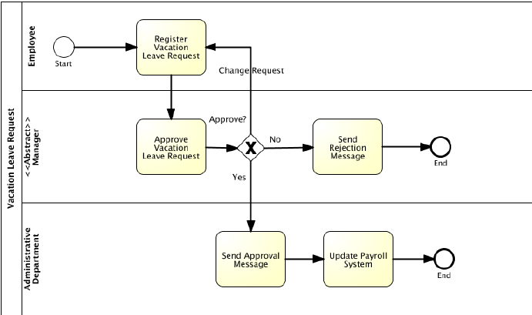

Approve CL/EL Request

register

**Employee**

Send CL/EL Request via Email